: How to create S3 bucket:

To create a bucket

Sign into the AWS Management Console and open the Amazon S3 console at https://console.aws.amazon.com/s3.

Click Create Bucket.

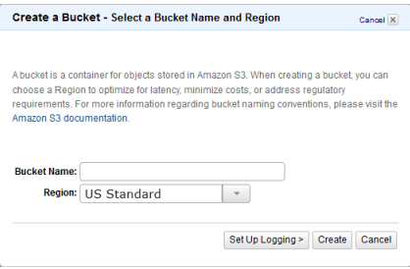

In the Create a Bucket dialog box, in the Bucket Name box, enter a bucket name.
The bucket name you choose must be unique across all existing bucket names in Amazon S3. One way to help ensure uniqueness is to prefix your bucket names with the name of your organization. Bucket names must comply with certain rules. For more information, see Bucket Restrictions and Limitations in the Amazon S3 Developer Guide.

Note
After you create a bucket, you cannot change its name. In addition, the bucket name is visible in the URL that points to the objects stored in the bucket. Ensure that the bucket name you choose is appropriate.
In the Region box, select a region. For this exercise, accept the default.
You can choose a region to optimize latency, minimize costs, or address regulatory requirements. Objects stored in a region never leave that region unless you explicitly transfer them to another region. For more information about regions, see Introduction to Amazon S3 in the Amazon S3 Console User Guide.
Click Create.

When Amazon S3 successfully creates your bucket, the console displays your empty bucket in the Buckets panel.

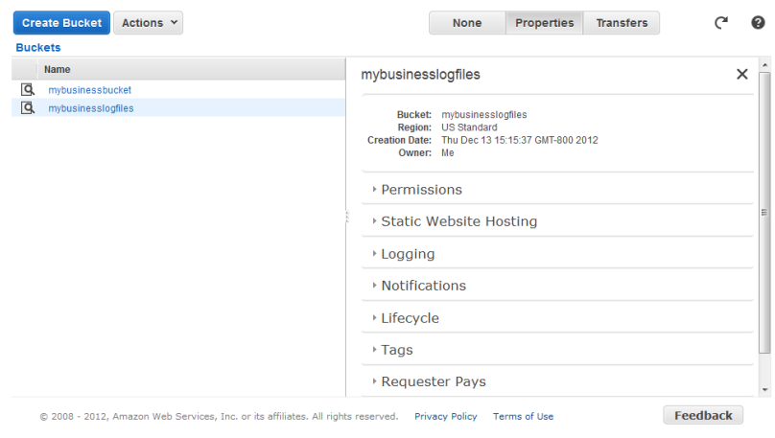
Reference: http://docs.aws.amazon.com/AmazonS3/latest/gsg/GetStartedWithS3.html

